# MARKETING SQL QUERIES

A. KPIs-

1. Conversion Rate

SELECT

COUNT(DISTINCT CASE WHEN converted = 1 AND user_id IS NOT NULL THEN user_id

END) * 100.0 /

COUNT(DISTINCT CASE WHEN user_id IS NOT NULL THEN user_id END) AS conversion_rate

FROM marketing;



1. Retention Rate (among converted users)

SELECT

COUNT(DISTINCT CASE WHEN converted = 1 AND is_retained = 1 AND user_id IS NOT NULL THEN user_id END) * 100.0 /

COUNT(DISTINCT CASE WHEN converted = 1 AND user_id IS NOT NULL THEN user_id END) AS retention_rate

FROM marketing;

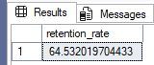

1. Channel Performance

SELECT

marketing_channel,

COUNT(DISTINCT CASE WHEN converted = 1 AND user_id IS NOT NULL THEN user_id END) * 100.0 /

COUNT(DISTINCT CASE WHEN user_id IS NOT NULL THEN user_id END) AS conversion_rate,

COUNT(DISTINCT CASE WHEN converted = 1 AND is_retained = 1 AND user_id IS NOT NULL THEN user_id END) * 100.0 /

COUNT(DISTINCT CASE WHEN converted = 1 AND user_id IS NOT NULL THEN user_id END) AS retention_rate

FROM marketing

WHERE marketing_channel IS NOT NULL

GROUP BY marketing_channel;

1. Variant Impact (Control vs Personalization)

SELECT

variant,

COUNT(DISTINCT CASE WHEN converted = 1 AND user_id IS NOT NULL THEN user_id END) * 100.0 /

COUNT(DISTINCT CASE WHEN user_id IS NOT NULL THEN user_id END) AS conversion_rate,

COUNT(DISTINCT CASE WHEN converted = 1 AND is_retained = 1 AND user_id IS NOT NULL THEN user_id END) * 100.0 /

COUNT(DISTINCT CASE WHEN converted = 1 AND user_id IS NOT NULL THEN user_id END) AS retention_rate

FROM marketing

WHERE variant IS NOT NULL

GROUP BY variant;

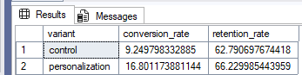

1. Language Conversion Trends

SELECT

language_preferred,

COUNT(DISTINCT CASE WHEN converted = 1 AND user_id IS NOT NULL THEN user_id END) * 100.0 /

COUNT(DISTINCT CASE WHEN user_id IS NOT NULL THEN user_id END) AS conversion_rate

FROM marketing

WHERE language_preferred IS NOT NULL

GROUP BY language_preferred;

1. Age Group Conversion Trends

SELECT

age_group,

COUNT(DISTINCT CASE WHEN converted = 1 AND user_id IS NOT NULL THEN user_id END) * 100.0 /

COUNT(DISTINCT CASE WHEN user_id IS NOT NULL THEN user_id END) AS conversion_rate

FROM marketing

WHERE age_group IS NOT NULL

GROUP BY age_group;

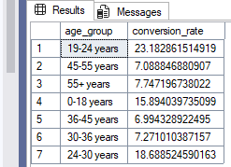

B. Insights to Look For

Which marketing channel has the highest conversion and retention rates?

SELECT

marketing_channel,

COUNT(DISTINCT CASE WHEN converted = 1 THEN user_id END) * 100.0 /

COUNT(DISTINCT user_id) AS conversion_rate,

COUNT(DISTINCT CASE WHEN converted = 1 AND is_retained = 1 THEN user_id END) * 100.0 /

COUNT(DISTINCT CASE WHEN converted = 1 THEN user_id END) AS retention_rate

FROM marketing

WHERE marketing_channel IS NOT NULL

GROUP BY marketing_channel

ORDER BY conversion_rate DESC, retention_rate DESC;

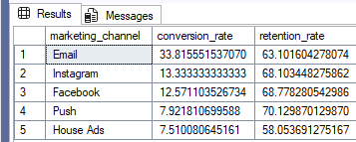

2. Is the personalization variant more effective than control?

SELECT

variant,

COUNT(DISTINCT CASE WHEN converted = 1 THEN user_id END) * 100.0 /

COUNT(DISTINCT user_id) AS conversion_rate,

COUNT(DISTINCT CASE WHEN converted = 1 AND is_retained = 1 THEN user_id END) * 100.0 /

COUNT(DISTINCT CASE WHEN converted = 1 THEN user_id END) AS retention_rate

FROM marketing

WHERE variant IS NOT NULL

GROUP BY variant

ORDER BY conversion_rate DESC;

3. Are certain age groups or languages more likely to convert or stay retained?

a) By Age Group:

SELECT

age_group,

COUNT(DISTINCT CASE WHEN converted = 1 THEN user_id END) * 100.0 /

COUNT(DISTINCT user_id) AS conversion_rate,

COUNT(DISTINCT CASE WHEN converted = 1 AND is_retained = 1 THEN user_id END) * 100.0 /

COUNT(DISTINCT CASE WHEN converted = 1 THEN user_id END) AS retention_rate

FROM marketing

WHERE age_group IS NOT NULL

GROUP BY age_group

ORDER BY conversion_rate DESC;

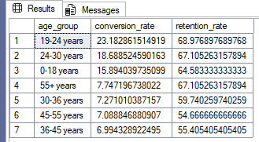

b) By Language Preferred:

SELECT

language_preferred,

COUNT(DISTINCT CASE WHEN converted = 1 THEN user_id END) * 100.0 /

COUNT(DISTINCT user_id) AS conversion_rate,

COUNT(DISTINCT CASE WHEN converted = 1 AND is_retained = 1 THEN user_id END) * 100.0 /

COUNT(DISTINCT CASE WHEN converted = 1 THEN user_id END) AS retention_rate

FROM marketing

WHERE language_preferred IS NOT NULL

GROUP BY language_preferred

ORDER BY conversion_rate DESC;

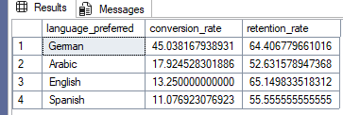

4. What is the subscription funnel from served → converted → retained?

SELECT

COUNT(DISTINCT user_id) AS total_served,

COUNT(DISTINCT CASE WHEN converted = 1 THEN user_id END) AS total_converted,

COUNT(DISTINCT CASE WHEN converted = 1 AND is_retained = 1 THEN user_id END) AS total_retained

FROM marketing;

